**SPEAKER RUANG**

**SPESIFIKASI TEKNIS PRODUK (Audio Paging System)**

**MASTER AMPLIFIER NUSTEC 40 CHANEL**

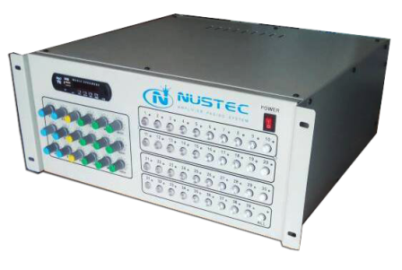

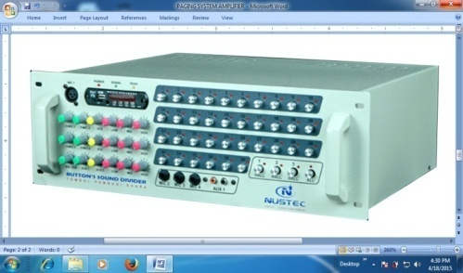

**MASTER AMPLIFIER NUSTEC 20 CHANEL**

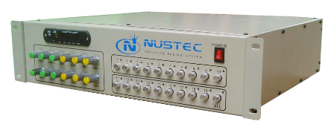

**NusTec** adalah perangkat

Audio Controller :

Adapun fungsi – fungsi yang dimaksud adalah :

1. Pertama, sebagai Power Amplifier + Mixer atau pengatur masukan dan keluaran suara sekaligus sebagai penguatnya dengan kapasitas hingga 60 Speaker.
2. Kedua, sebagai Audio Selector yang mengatur penyebaran keluaran suara yang dapat disesuaikan dengan bagian penerima suara yang dituju ( semua ruang atau acak ).
3. Ketiga, sebagai Multimedia Input Terminal yang dapat memutarkan file-file suara dari media penyimpanan micro seperti : Flashdisk dan Memory Card.

Spesifikasi :

* Power Source AC 220-240 V 50/60 Hz
* Rated output 250 W
* Power consumption 124 W
* Frequency Response 50-18 , 000 Hz , + / - 3 dB
* Distortion Less than 0.3 % at 1 kHz , 1/3 Rated Power
* Input MIC 1 , MIC 2 , 3 MIC , MIC 4 -52 dBV ( 2.5 mV ) , 600 Ohm , socket Jack akay .
* AUX 1 , AUX 2 -10 dBV ( 316mV ) , 10 kOhm , not , RCA socket 2 Pin Jack
* Output Direct Line 4-16 Ohm , 42 Ohm ( 100 V )
* 1-36 -channel sound divider button ( For indoor ) , 3 swich hall ( Swich divider to the page ) and all of the buttons ( To turn all sound / speakers )
* S / N Ratio More than 65 dB ( MIC1- MIC3 ) , More than 75dB (AUX 1 - AUX2)
* Tone Control Lo : + / - 10 dB at 100 Hz , mid : +/- 10 db at 50 Hz , High : + / - 10 dB at 10 kHz
* Power indicator LED , LED Signal
* Panel Finish : Grey / Case : Steel Plate , Grey
* Dimensions 530 ( W ) x 180 ( H ) x 410 ( D ) mm
* Type : Condenser Microphone
* Directivity : Ultra - Cordioid
* Frequency Response : 80 - 12000Hz
* Sensitivity : 10mv/pa
* Output Impedance : 2KΩ
* Pick-up Distance : 5 -10 cm
* Power Source : DC 1.5 V x 2AA

**Desk Microphone TARGA**

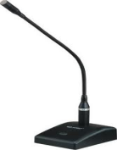

* Rated Input Selection/Impedance : 6W, (100V Line)
* Frequency Response : 100 ~ 12,000 Hz
* Sound Pressure Level (1W/1m) : 90dB
* Speaker Components : 16cm Dynamic Speaker (6 ")
* External Dimensions (WxHxD) : 290 x 214 x 150mm
* Weight product : 2.2kg
* Material : Enclosure: Wood, grille: Cloth
* Color : Enclosure: Light Grey, Grille : Light Grey

**Speaker Monitor**

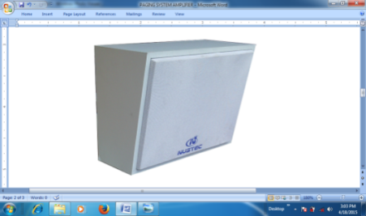

**Speaker Zone ( Indoor )**



* Rated Input Selection/Impedance : 6W, (100V Line)
* Frequency Response : 100 ~ 12,000 Hz
* Sound Pressure Level (1W/1m) : 90dB
* Speaker Components : 16cm Dynamic Speaker (6 ")
* External Dimensions (WxHxD) : 290 x 214 x 150mm
* Weight product : 2.2kg
* Material : Enclosure: Wood, grille: Cloth
* Color : Enclosure: Light Grey, Grille : Light Grey

**Horn Speaker TOA ZH-615**

**( Out Door )**

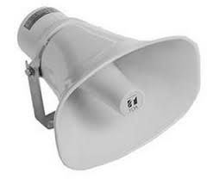

* Rated Input 25W (16)
* Frequency Response: 200~6.500 Hz
* Sound Preasure Level: 117dB (1W/1m, in anechoic chamber)
* Material: Horn: Aluminium, Color: Ash White
* Unit cover: ABS resin, Color: Dark Gray
* 30 W Mono Amplifier
* 220 V AC
* Input : 2 Aux, 2 Mic
* Solid Steel Case
* Dimensi : 17 cm X 5 cm X 14 cm
* Silver Only

**Ampli pengajar ( teaching amplifier ) atu di pake juga untuk amplu upacara**

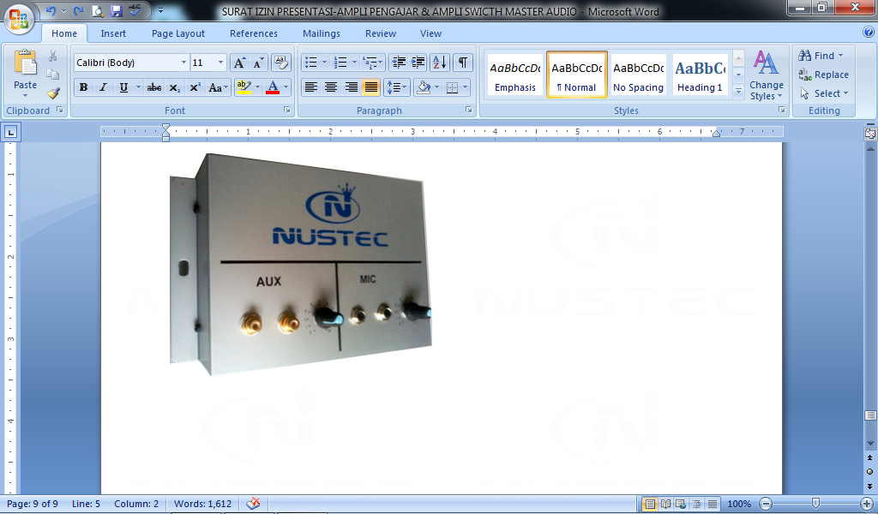

* Sensitivitas : -72dB
* Respon Frekuensi : 100-10.000Hz
* Output : 600 Ohm
* Tegangan Operasi : 3V atau 1,5V
* Jarak Efektif : 15-30m
* Isi  : 1 pcs

**Microphone Wireless Portable TARGA ( mic pengajar )**

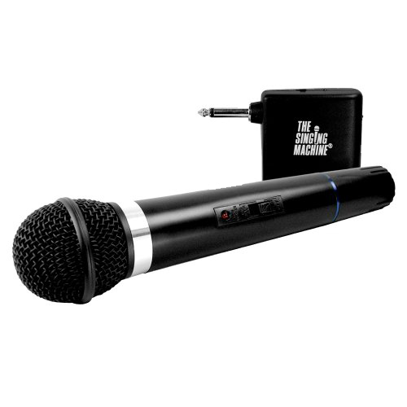

* Type : Dynamic Microphone
* Directivity : Undirectional
* Impedance : 600 Ohms
* Sensitivity : - 76 dB

**Microphone Kabel BS 828 ( mik upacara )**

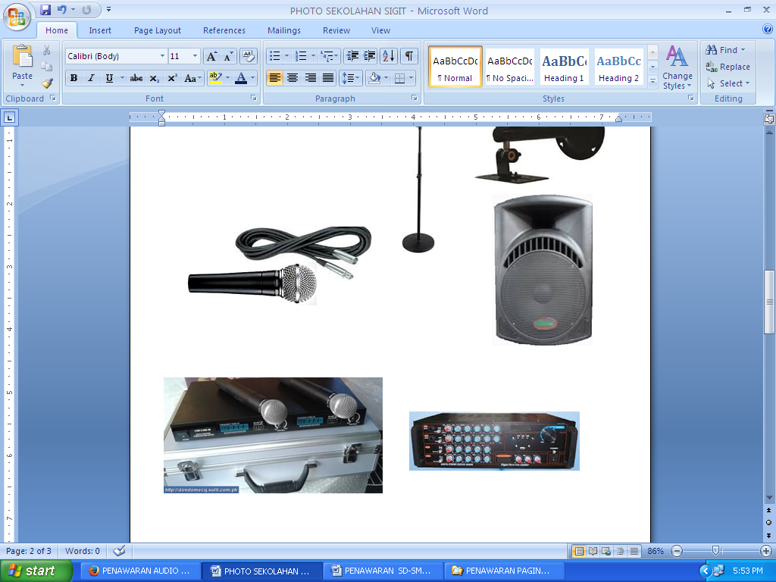

Spesifikasi Stand Mic :

* Kaki Bulat
* Bahan Besi
* Putaran 360 derajat
* Tinggi min = 100cm
* Tinggi Maks =.160cm
* Finishing =Warna Hitam

**Stand Mic Black Spider**

**( MS – 84 )**

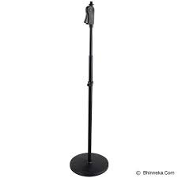

**Speaker CEILLING ZS-646R**

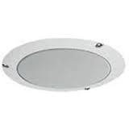

* Flush Ceiling Mount
* Respon Frekuensi : 100-12.000Hz
* Input Rata-Rata : 6W
* Rated Input Selection / Impedansi : 6W,3W,1.5W,0.8W (100VLine)
* Dimensi Eksternal : 191 x 74mm
* Berat : 610 g
* Speaker Mounting Hole: 150 mm
* Hasil akhir : Panel; ABS Resin, Off White

**LOGO / MERK DAGANG**

